**CPSC 1520 Assignment 1: Album Creator**

**Weight 15%**

**Dure Sunday February 18th, 2024 @11:59pm**

# **Introduction**

This assignment builds on what you have learned in class over the last couple of weeks. This will test you on forms and form elements, events, conditionals, and templating.

For this assignment, you’re required to finish the application called “Album Creator.” This application needs to be able to create album cards with a title, description, and some cover art. Bootstrap is used as the styling solution. So you will be adding the removing Bootstrap classes rather than Tailwind. The Bootstrap classes will be highlighted for you but the add and remove functionality of the classes is still accomplished the same way as you did in class.

In order to add an album the form has to have valid input before you can render the album card template to the DOM.

1. The select element must not have the default option “select album art”. If it does you will display and give the end user feedback that they must select an image before creating a card.
2. The Album title needs to be between 0 and 20 characters in length before an album card can be created in addition the field can not be left empty. If either of these conditions occur on the submit event display feedback to the end user to fix the entry
3. The description needs to be between 0 and 40 characters in length. Just like the Album title this field should display a hint when the field is left empty or exceed the maximum character length.

**Adding A Card Screenshot**

Below is an example of the interface when you filled out the form with the following parameters.

1. Album Title My Favourites
2. Album Art cassette.jpg
3. Artwork Description the best overall songs agreed upon by everyone.

**Invalid Form Submission Example**

The following are examples of the user interface when all fields are in the following conditions

**All fields are not filled out.**

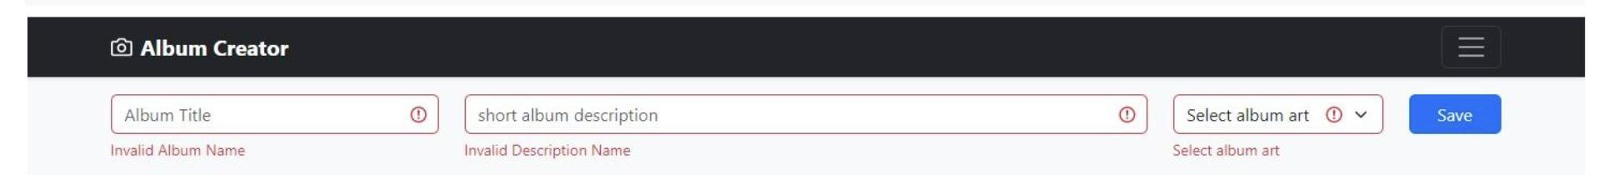

**Single Field Errors**

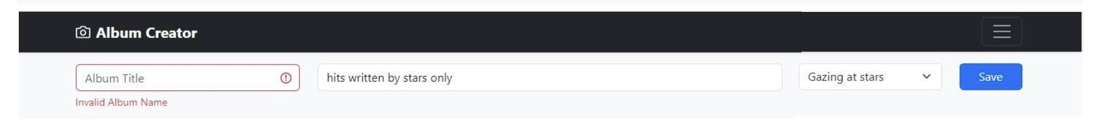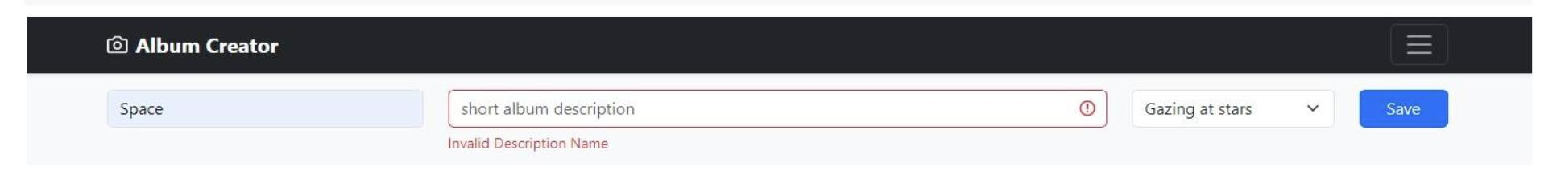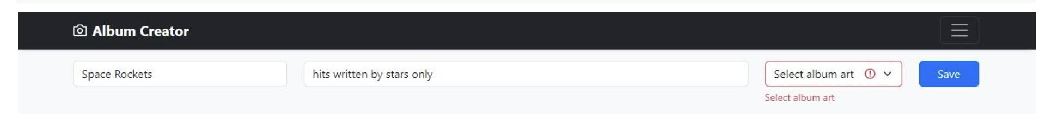

**Two Field Errors**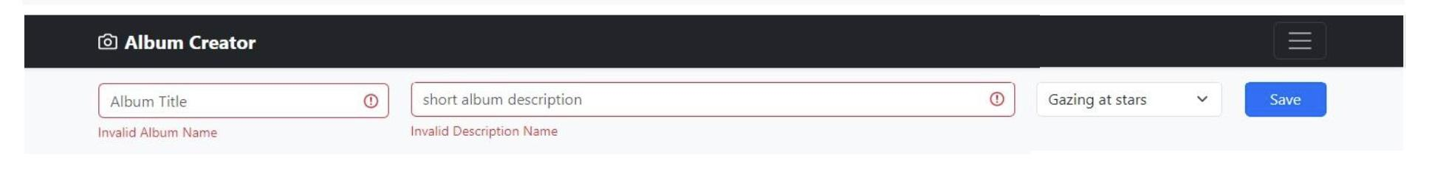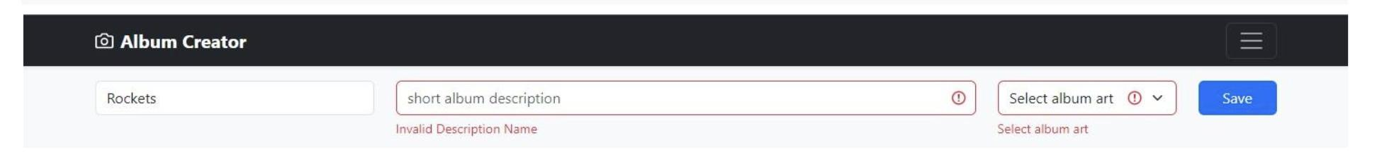

# **Task Form Submit Event**

Add a submit event to the form, pass the event object to the handler function. Stop the forms default behavior, submitting refreshing the browser so you can validate the form inputs.

Create references for the **“album title**”, **“album description”**, and the **album art”** form elements.

# 

# 

# 

# **Task Validation Errors**

For this task you have to validate the form elements **“album title**”, **“album description”**, and **album art”**. Below you will find a list of each element and what validation rules need to be applied to each element. Each element has a div tag with the class invalid-feedback. This displays a hint to the end user giving them help on how to fill out the form input. If an element fails your validation tests then add the is-invalid class to the input or select element. Once the user fixes the error for example too many characters or leaving an input element empty, clear the error by removing the is-invalid class.

**Validation Rules**

|  |  |  |
| --- | --- | --- |
| **Album Title** | **Album Description** | **Album Art** |
| invalid if input value is empty.  Perform this check on the submit event | invalid if input value is empty.  Perform this check on the submit event | invalid if the select element option value returns the text “Select album art”.  Perform this check on the change event. |
| invalid if the album name is greater than 10 characters.  Perform this check on the input event | invalid if the album name is greater than 30 characters.  Perform this check on the input event |

# **Task Validation Success**

You have been given the markup for the album card. You can find this in the README.md document in the assignment folder. Create a template from the markup and seed the form data using the placeholder syntax to display the selected image, album title and the description.

<div class="col">

<div class="card shadow-sm">

<img class="bd-placeholder-img card-img-top" src="ALBUM IMAGE SELECTION HERE"/>

<div class="card-body">

<h5 class="card-title">ALBUM DESCRIPTION HERE</h5>

<p class="card-text">ALBUM TITLE HERE</p>

</div>

</div>

</div>

Once you have the album card template completed add the element to the div with the id of “container”. This is an example of display templating.

Reset the values of the form inputs and the select element to their initial states.

# **Submission**

Upload your completed assignment to Netlify. Submit the Netlify URL to Moodle.

Create a github repository for your assignment. Submit the GitHub repository URL to Moodle.

If the Netlify URL produces a **404 error,** marks will be deducted. The GitHub repository should be your assignment files not the assignment folder. If you fail to display your assignment files on the main branch of the github repository marks will be deducted.

# Marking key

|  |  |  |  |
| --- | --- | --- | --- |
| Tasks | Grade | Marks | Total |
| **Form Event Listener**  Event listener added and page does not refresh the page.  Form does not submit if any of the form elements fail validation. |  | 1  1 | **2** |
| **Validation Errors**  **Album Title**  Fails validation if the field contains more than 15 characters  Fails validation if the field is empty.  Hints are shown for both validation errors.  Validation hints are removed when the user corrects the error.  **Album Description**  Fails validation if the field contains more than 305 characters  Fails validation if the field is empty.  Hints are shown for both validation errors.  Validation hints are removed when the user corrects the error.  **Album Art**  Select element fails validation if the option select album art is chosen. Hint is shown if validation fails. Validation errors are cleared when the value of the element is correct. |  | 5    5    5 | **15** |
| **Validation Success**  Template used along with the form input values.  Template add to the DOM using appropriate method..  Form elements reset once templated added to the DOM. |  | 3 | **3** |
| **Submission**  Netlify Deployment URL submitted and site displays with no errors  GitHub URL submitted and repository displays the assignment root files on the main branch. |  | 4 | **5** |

# Marking Rubric

|  |  |
| --- | --- |
| Marks | 5 Marks Criteria |
| 5 | Task was completed with the highest of proficiency adhering to best practices and followed subject matter guidelines all tasks were completed to a professional standard. |
| 4 | Task was completed well some minor mistakes. Well above average work shows good understanding of the task and high degree of competence |
| 3 | Satisfactory work some features missing or incorrectly implemented. Show a moderate level of understanding in the task with room for improvement. |
| 2 | Below average work. Task was poorly complete. Show understanding of the task and the requirements to implement but implementation was poorly executed. |
| 1 | Some of the task was completed. Showed a lack of  understanding in the subject matter and very poorly executed |
| 0 | Not completed. |

|  |  |
| --- | --- |
| Marks | 3 Marks Criteria |
| 3 | Proficient shows a high degree of competence in completing task. |
| 2 | Capable above average degree of competence in completing task |
| 1 | Satisfactory shows a satisfactory degree of competence in completing task. |
| 0 | Shows a limited degree of competence in completing task. |

|  |  |
| --- | --- |
| Marks | 1 Marks Criteria |
| 1 | Task Completed satisfactorily |
| 0 | Task was not executed. |